Application: Social Media Feed Processing
Aim
To solve the recurrence relation
T(n)=T(n−1)+n
using the substitution method and determine its asymptotic complexity.
Problem Statement
A social media platform processes user posts using a recursive algorithm.
The recurrence relation is
T(n)=T(n−1)+n
The objective is to expand the recurrence using the substitution method and analyze its performance for large input sizes.
Objectives
- To understand recursive algorithms.
- To solve recurrence relations.
- To apply the substitution method.
- To analyze time complexity using asymptotic notation.
Theory
Many recursive algorithms are represented using recurrence relations.
A recurrence relation expresses the running time of a problem in terms of smaller subproblems.
The substitution method repeatedly expands the recurrence until the base condition is reached.
Algorithm
Step 1
Read the number of posts n.
Step 2
If
n==1
return 1.
Step 3
Otherwise compute
T(n)=T(n−1)+n
using recursion.
Step 4
Display the total processing cost.
Step 5
Analyze the complexity.
Source Code
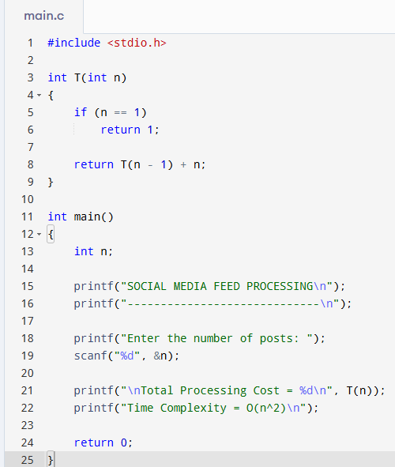
Output
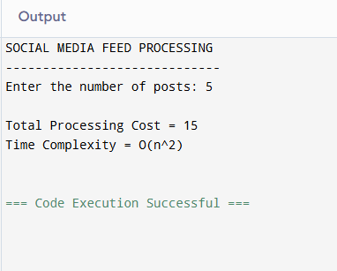
Substitution Method
Given
T(n)=T(n−1)+n
Expand once
= T(n−2)+(n−1)+n
Expand again
= T(n−3)+(n−2)+(n−1)+n
Continue
= T(1)+2+3+...+n
Using the formula
1+2+3+...+n

= n(n+1)/2
Therefore
T(n)

= 1+n(n+1)/2
Ignoring constants
T(n)=Θ(n²)
Asymptotic Analysis
Worst Case
O(n²)
Average Case
Θ(n²)
Best Case
Ω(n²)
Performance Analysis
Every recursive call performs additional work equal to the current input size.
The total work becomes
1+2+3+...+n
which grows quadratically.
For large social media platforms handling millions of posts, this algorithm becomes inefficient due to increased execution time.
Result
The recurrence relation
T(n)=T(n−1)+n
is solved using the substitution method.
The final complexity obtained is
Θ(n²)
Conclusion
The substitution method proves that the given recursive algorithm has quadratic time complexity. As the number of posts increases, the execution time also increases rapidly. Therefore, this approach is not suitable for very large datasets, and more efficient algorithms should be preferred.

